**STRUCTURED DESIGN**

**AND**

**UML DIAGRAMS**

Data Flow Diagrams

Context Diagram(Level 0 DFD)

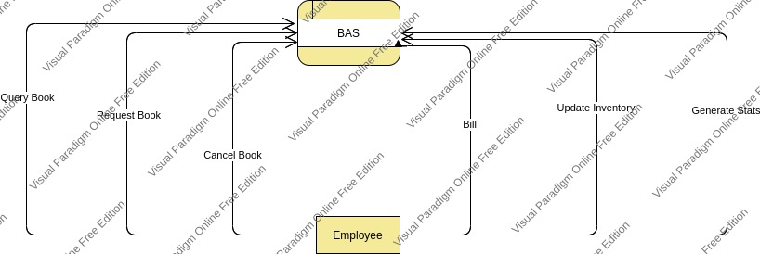

Level 1 DFD:

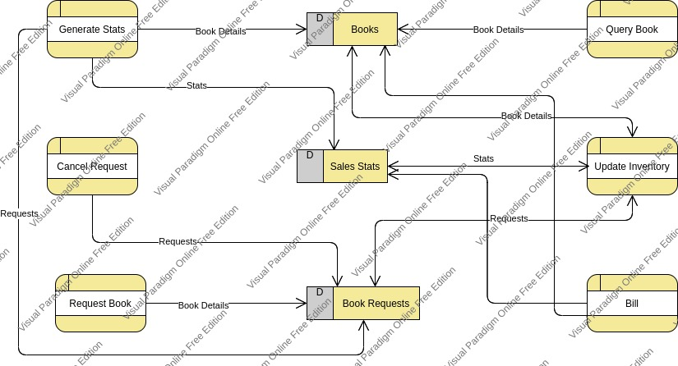

Data Dictionary:

Book Details: ISBN + Book Name + Aurhor Name + Publication + Price + Quantity.

ISBN: String.

Book Name: String

Author Name : String

Publication: String

Price: Float

Quantity: Integer.

Stats: {Book Details}* + Revenue + Profit+ Total Sale

Revenue: Float

Profit: Float

Total Sale: Integer.

Requests: {Book Details}* + Customer Name

Customer Name: String.

**UML Diagrams**

Use Case :

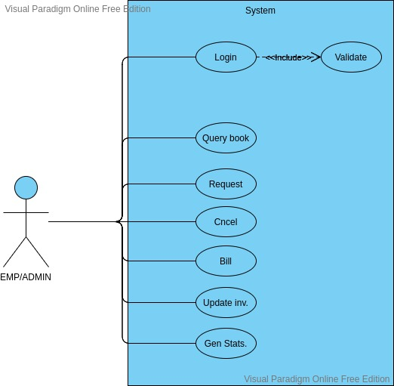

Class Diagram:

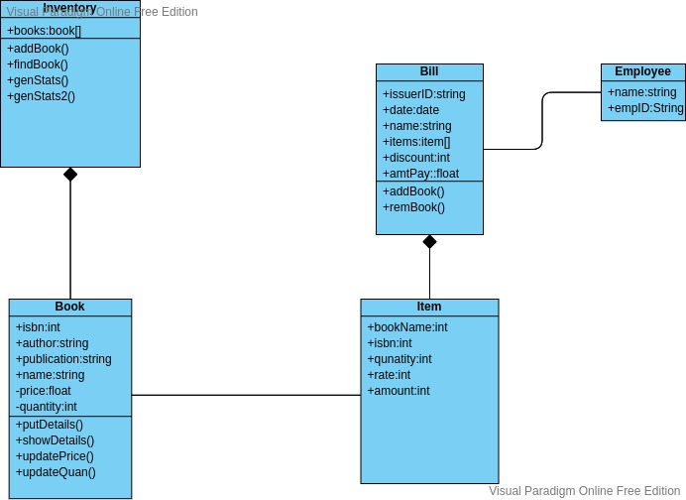

Sequence Diagram:

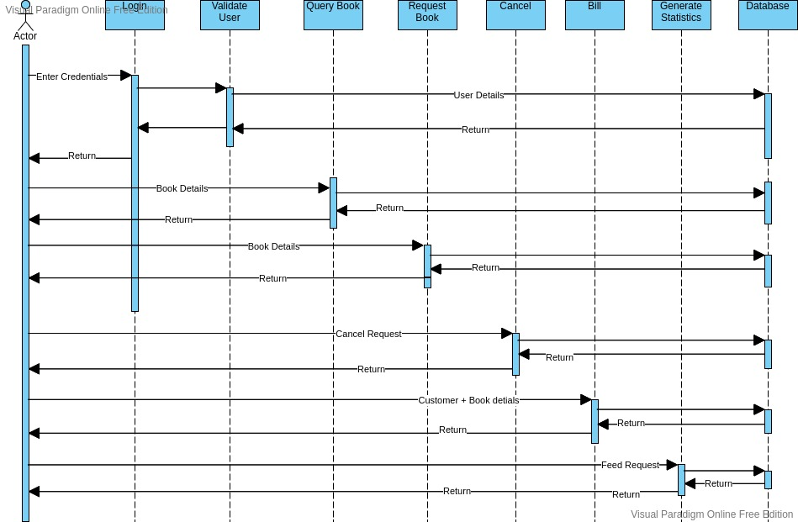

State Diagram:

